Online Shopping Trends 2025: Global and Indian Market Analysis
Online shopping, also known as e-commerce, has transformed from a convenience into a dominant force shaping global consumer behaviour. In 2025, it represents one of the fastest-growing sectors of the digital economy, connecting billions of consumers and millions of businesses worldwide. The expansion of internet access, smartphone usage, secure digital payments, and reliable logistics has made it easier than ever for consumers to browse, compare, and purchase products from anywhere.
Recent trends reveal that online shopping is no longer driven solely by price or convenience. Shoppers today seek personalised, immersive, and value-driven experiences, often powered by artificial intelligence (AI), augmented reality (AR), and data analytics. Social media platforms have evolved into shopping hubs, giving rise to social commerce, where discovery and purchase happen in the same space. Mobile commerce now dominates total e-commerce transactions, reflecting the shift to a “mobile-first” consumer base.
Sustainability has also emerged as a major consideration in online buying decisions. Consumers increasingly prefer brands that demonstrate ethical sourcing, eco-friendly packaging, and transparent business practices. Moreover, faster delivery expectations, flexible payment options, and reliable return policies have become critical differentiators for online retailers.
In emerging economies such as India, online shopping trends are expanding beyond metropolitan cities into smaller towns and rural areas, driven by affordable smartphones, local-language interfaces, and digital payment systems like UPI. As a result, e-commerce is not only redefining retail but also reshaping employment, logistics, and consumer lifestyles.4

Market Overview & Growth Context

Global E-commerce scale
- Global consumer e-commerce spending rose by ~7.65% year-on-year from 2023 to 2024
- The share of online retail in total global retail is ~19.9%, with projections to ~22.5% by 2028.
- A forecast estimate: ~2.77 billion people globally (≈33% of the world’s population) are online shoppers in 2025; projected to rise further.
- Growth is moderating compared with earlier years (e.g., average ~16.5% annual growth 2014–2024) but remains substantive.

Regional Variation
- While strong growth continues, mature markets (US, Western Europe) grow at lower rates; emerging markets (Asia-Pacific, Latin America) offer higher upside.
- For example, in the Asia-Pacific region: social commerce adoption is already very high (see later section).

Implications
- Online shopping is now mainstream rather than niche — it must be a strategic channel for any retailer/brand.
- However, the “easy growth” phase is waning in some places; differentiation, experience & operational excellence matter more now.
- For markets still ramping (emerging economies, smaller cities) there is significant oppo

Challenges & Risks

Competitive saturation & margin pressure
- As more players enter online retail (including marketplaces, social platforms), differentiation is harder and cost pressure (ads, fulfilment) rises.
- Returns are a growing cost: For example, in holiday season 2024 the return rate in the US rose to ~28% compared to ~20% in 2023.

Infrastructure & fulfilment complexity
- Meeting consumer expectations (fast/free delivery, flexible returns) requires investment in warehousing, logistics, reverse logistics — smaller players may struggle.
- Cross-border and global commerce bring complexities: duties, customs, payment fraud, currency fluctuations, regulatory risk.

Technology adoption & trust issues
- Use of AI, voice, AR/VR brings opportunities — but also risks: user trust, data privacy, implementation cost. For example, a study shows trust is key to consumer acceptance of AI in shopping.
- Sustainability claims may backfire if not genuine: green-washing risks, consumer skepticism.

Advantages of Online Shopping Trends

1. Convenience & Accessibility
- 24/7 availability: Shoppers can browse and buy anytime without visiting physical stores.
- Mobile and social commerce allows shopping from anywhere.
- Especially beneficial for consumers in remote areas or those with limited mobility.

2. Wider Product Selection
- Consumers can access global products beyond local stores.
- Online marketplaces aggregate many brands in one platform.
- Niche products and international brands are more easily available.

3. Price Comparison & Deals
- Online shoppers can compare prices instantly and access discounts or flash sales.
- Dynamic pricing, personalized offers, and AI-driven recommendations improve savings.

4. Personalization & Technology Integration
- AI algorithms provide personalized product suggestions.
- AR/VR technologies allow virtual try-ons (clothing, makeup, furniture).
- Voice commerce enables hands-free shopping.

5. Social Commerce & Community Influence
- Shopping via social media platforms is growing globally, especially in Asia-Pacific.
- Peer reviews, influencer recommendations, and viral trends influence purchases.

6. Efficient Delivery & Returns
- Fast shipping and doorstep delivery save time.
- Flexible return options improve the post-purchase experience.
- Innovations like lockers, micro-fulfillment centers, and same-day delivery enhance convenience.

7. Data & Insights for Shoppers
- Browsing and purchase history help users discover relevant products.
- Targeted notifications reduce the time spent searching for desired items

Disadvantages of Online Shopping Trends

1. Lack of Physical Interaction
- Consumers cannot touch, feel, or try products physically.
- Leads to disappointment, especially for clothing, furniture, or premium goods.
- Virtual try-on and AR help, but are not always perfect.

2. Delivery & Fulfillment Issues
- Delayed or failed deliveries can frustrate customers.
- Delivery costs may increase total purchase value.
- International shipments face customs, duties, and longer lead times.

3. Returns & Refund Hassles
- Returning products can be cumbersome or costly.
- Policies vary across retailers, causing inconsistency.
- High return rates can be operationally challenging for sellers.

4. Security & Privacy Concerns
- Online shopping requires sharing personal and financial information.
- Risk of hacking, phishing, and fraudulent transactions exists.
- Data misuse by some platforms can erode trust.

5. Impulse Buying & Overspending
- Targeted ads, AI recommendations, and easy checkout encourage impulsive purchases.
- BNPL (Buy Now Pay Later) schemes may increase debt among consumers.

6. Dependency on Technology
- Mobile apps, websites, and internet access are essential.
- Poor connectivity, app glitches, or server downtime can hinder purchases.

Key Shopping-Patterns & Consumer Behaviour Trends

1. Mobile-First & Multi-Device Use



- Most online purchases are now done via smartphones (mobile commerce) — a shift from desktop acting as primary device. For example: ~76% of U.S. adults shop via smartphones.
- Shoppers often use multiple devices: browse on phone, compare on tablet/desktop, purchase later.
- Because of mobile usage, the checkout process, app experience, and mobile-friendly site are now very important for conversion.

2. Social Commerce & Influencer Effects




- Social platforms (e.g., TikTok, Instagram) are no longer just for discovery — many purchases happen within social apps.
- Influencer content, user-generated reviews, live-stream shopping are shaping what people buy and when.
- Trust via social proof matters: consumers follow peers/micro-influencers when buying. For example, research on Chinese shopping festival “Double 11” shows herd behaviour and peer-effects.

3. Value, Discounting & Price Sensitivity


- Many consumers are very price-sensitive: focusing on discounts, deals, free shipping. For example: value for money is a key factor in purchase decisions.
- Economic pressures (inflation, cost-of-living) are making shoppers more selective, switching brands, hunting deals.
- They expect transparency: “cheap” doesn’t always mean bad quality, but trust matters (see next point).

4. Trust, Brand & Experience Over Just Price

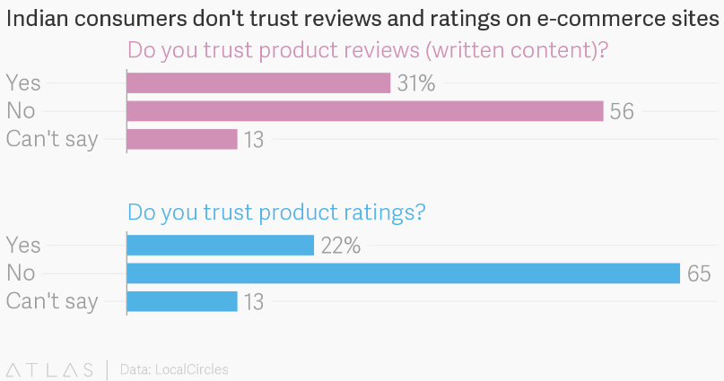

- Even while seeking value, shoppers still care about brand trust, product reviews, authenticity. If they don’t trust the site or the product, they won’t buy.
- Experience (ease of checkout, fast delivery, good customer service) plays into loyalty: a frictionless experience encourages repeat purchase.

5. Delivery & Fulfillment Expectations


- Consumers increasingly expect faster delivery (same-day / next-day) especially younger shoppers.
- More attention to logistics: convenience of delivery, clear tracking, easy returns influence whether someone completes a purchase.
- For everyday / convenience items, even slightly slower delivery can affect choice

What to watch out for in the next 1-2 years
- Growth of voice commerce (shopping via smart-speakers or voice-assistants) will rise.
- Increase in live shopping events integrated with social platforms, especially in Asia.
- Greater adoption of local currency/alternative payment methods in emerging markets.
- More focus on omni-channel (blending online + offline) even for e-commerce-first brands.
- Supply-chain resilience: disruptions (logistics, raw-materials) may affect product availability and shipping costs.
- Regulatory shifts: e-commerce taxation, data privacy, cross-border trade laws.

Conclusion
Online shopping continues to experience rapid growth globally and in emerging markets like India, driven by technology, mobile adoption, and expanding internet access. Consumers increasingly expect personalized experiences, fast and reliable delivery, and seamless mobile and social commerce integration. Emerging trends such as AI-driven recommendations, AR/VR try-ons, voice commerce, and sustainable practices are shaping the future of online retail.
For businesses, success depends on adapting to evolving consumer behaviors, leveraging technology, optimizing logistics, and addressing sustainability and ethical concerns. Those who embrace innovation, social engagement, and local market adaptation will thrive in the competitive e-commerce landscape.

